**Product Catalog System - Spring Boot Application**

**By: Rachit Sharma**

**Date: September 9, 2025**

1. **Application Overview**

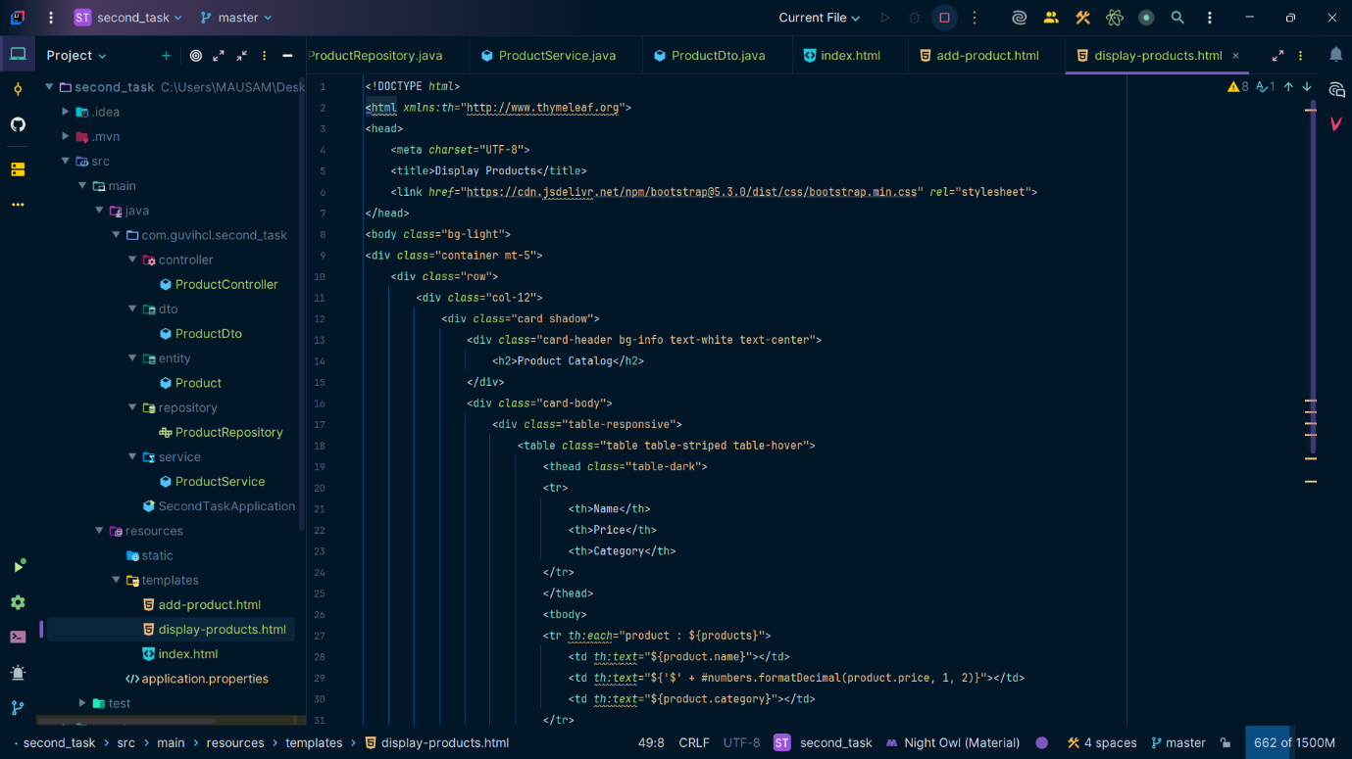

This is a Product Catalog System built with Spring Boot, Spring Data JPA, Thymeleaf, and MySQL.

**2. Home Page**

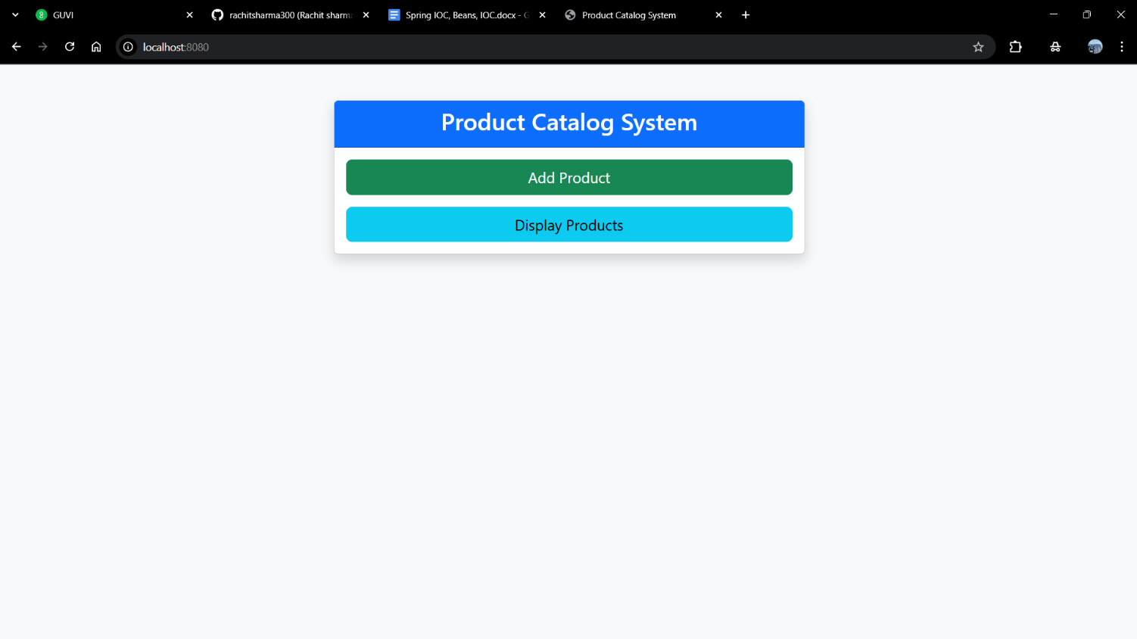

URL: <http://localhost:8080/>

The home page provides two main options:

* Add Product: Navigates to the product input form
* Display Products: Shows all products in a table format

**3. Add Product Form**

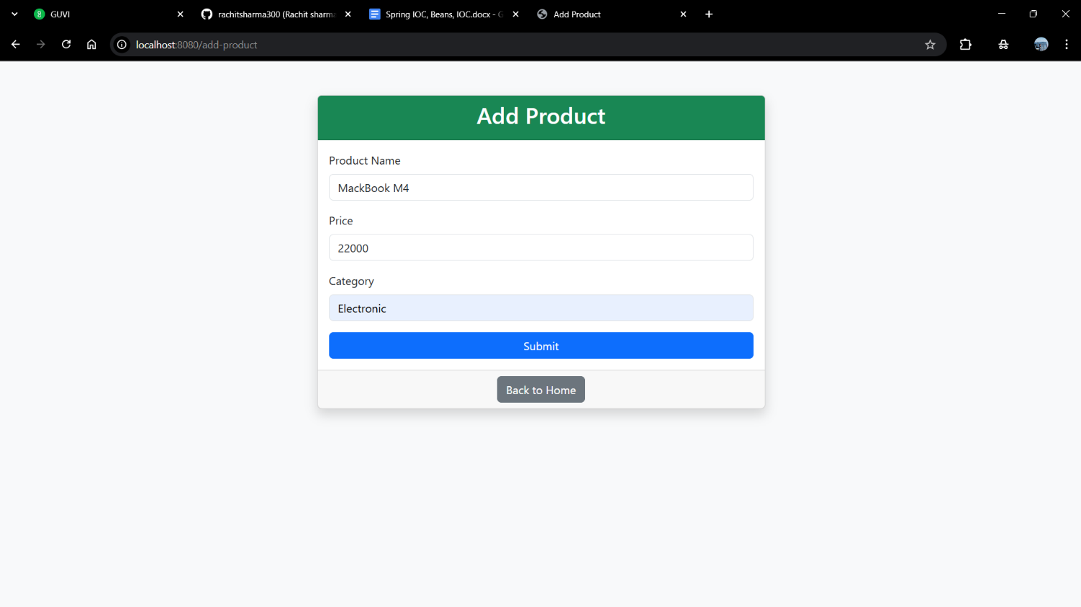

URL: <http://localhost:8080/add-product>

The form includes fields for:

* Product Name: Text input for the product name
* Price: Numeric input for the product price
* Category: Text input for the product category

**4. Product Catalog Display**

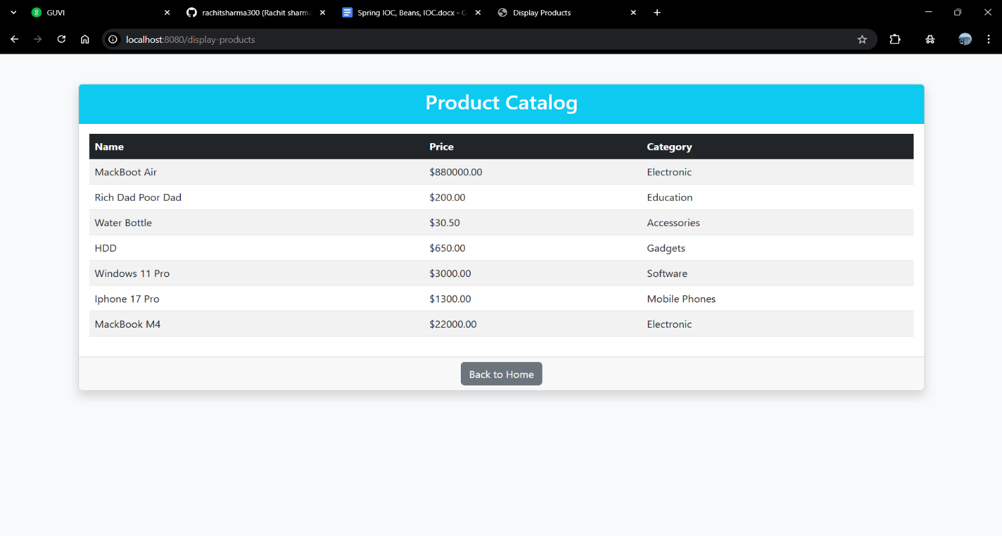

URL: <http://localhost:8080/display-products>

Displays all products in a responsive table with columns:

* Name: Product name
* Price: Formatted price with currency symbol
* Category: Product category

**5. Database Structure**

* id: BIGINT (Primary Key, Auto Increment)
* name: VARCHAR(255) (Not Null)
* price: DOUBLE (Not Null)
* category: VARCHAR(255) (Not Null)

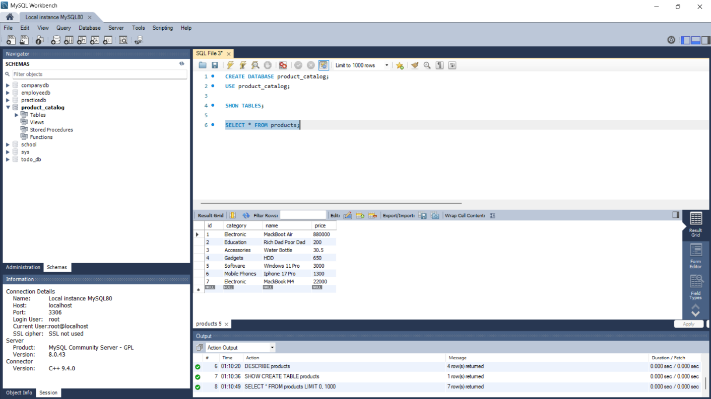

**Happy Coding🧑🏻‍💻**